**PUSL2021 Computing Group Project**

**Technical Functional Specification 2024/25**

**AI POWERED VIRTUAL-TRY-ON MOBILE APPLICATION – “FITON”**

Group No: 2

Group Members: 9

|  |  |  |
| --- | --- | --- |
| **ID** | **Name** | **Degree Program** |
| 10952358 | I B Y D Irugalbandara [AI Lead] | Technology Management |
| 10953783 | R J Ganegame [Backend Lead] | Computer Science |
| 10953336 | R Y M M P Rajakaruna [UI Lead] | Technology Management |
| 10953476 | R P W D G Rajapaksha | Computer Science |
| 10953524 | H G L D K Hathnapitiya | Computer Science |
| 10953572 | H H D J V Herath | Computer Science |
| 10953233 | G Kishalan | Computer Security |
| 10953377 | G Sathushan | Computer Networks |
| 10953332 | A R Ihsaan | Computer Networks |

Table of Contents

6.1. Development Methodology 1

6.1.1. SDLC Methodology - Agile Scrum 1

6.1.2. Work Distribution Between Sprints 1

6.1.3. GitHub Project Management 2

6.1.4. Project Timeline 5

6.2. Programming Languages & Tools 8

6.2.1. Main Languages & Frameworks 8

6.2.2. Tools 8

6.3. Algorithms 10

6.3.1. AI-Based - Virtual Try-On Algorithm (CatVTON) 10

6.3.2. AI-Based - Personalized Recommendation Algorithm (BERT4Rec) 10

6.3.3. AI-Based - Fashee Chat Algorithm 11

6.4. Chapter Summary 11

References 12

Appendixes 12

Team Structure 12

List OF Tables

Table 1. Agile Sprints 2

Table 2. Agile Timeline 5

List Of Figures

Figure 1. Virtual Try On Algorithm [Flow Chart] 10

Figure 2. Clothing Recommendation Algorithm [Flow Chart] 11

Figure 3. Fashion Assistant Algorithm [Flow Chart] 12

Figure 4. Organizational View 14

# 6.1. Development Methodology

FitON system development uses a planned approach to make sure that it is effective, flexible, and collaborative. For the Software Development Life Cycle (SDLC), **Agile Scrum** was chosen because it allows for iterative development, constant feedback, and quick delivery of crucial components.

### 6.1.1. SDLC Methodology - Agile Scrum

Agile Scrum (Schreiner, M; Sluyter, M;, 2021) is a way to make software that focuses on teamwork, being flexible, and getting feedback from customers. The concept breaks down the development process into manageable, small units called sprints, which usually last one to two weeks.

The key principles of Agile Scrum include:

* **Focused on Working Together with Clients Rather Than Contract Negotiation**: Ongoing communications with stakeholders make sure that the final product fulfills business requirements.
* **Adapting to Change Rather Than Following a Strict Plan**: Instead of following a strict plan, agile allows changes depending on real-time feedback.
* **Delivering Working Software Frequently**: Instead of delivering a complete system at once, working software is released in sections.
* **Self-Organizing Teams**: The development team takes ownership of tasks and works together to achieve goals.
* **Continuous Improvement**: After each sprint, the team conducts a retrospective to find out what went well and what needs improvement.

### 6.1.2. Work Distribution Between Sprints

The FitON project has a well-organized **8-week development plan** with work broken down into several sprints to make sure that all features are finished on time. Each sprint focuses on specific modules, balancing the parallel team works on UI/UX, backend functionality, and AI model integration.

* **Sprint 1**: Database design, UI/UX for key screens, initial backend setup.
* **Sprint 2**: Implementation of onboarding, login features, and user profile management.
* **Sprint 3**: Development of TryOn feature and product catalog UI.
* **Sprint 4**: Technical Functional Specification and Interim Presentation.
* **Sprint 5**: Shopping cart, payment integration, and order processing.
* **Sprint 6**: AI recommendation system and premium subscription features.
* **Sprint 7**: Seller dashboard, analytics, and performance improvements.
* **Sprint 8**: Final testing, bug fixes, and deployment preparation.

Each sprint begins with a **Sprint Planning Meeting**, followed by **Daily Standups** to track progress. The sprint consists of a **Sprint Review** and **Sprint Retrospective**, making continuous improvements.

### 6.1.3. GitHub Project Management

Table . Agile Sprints

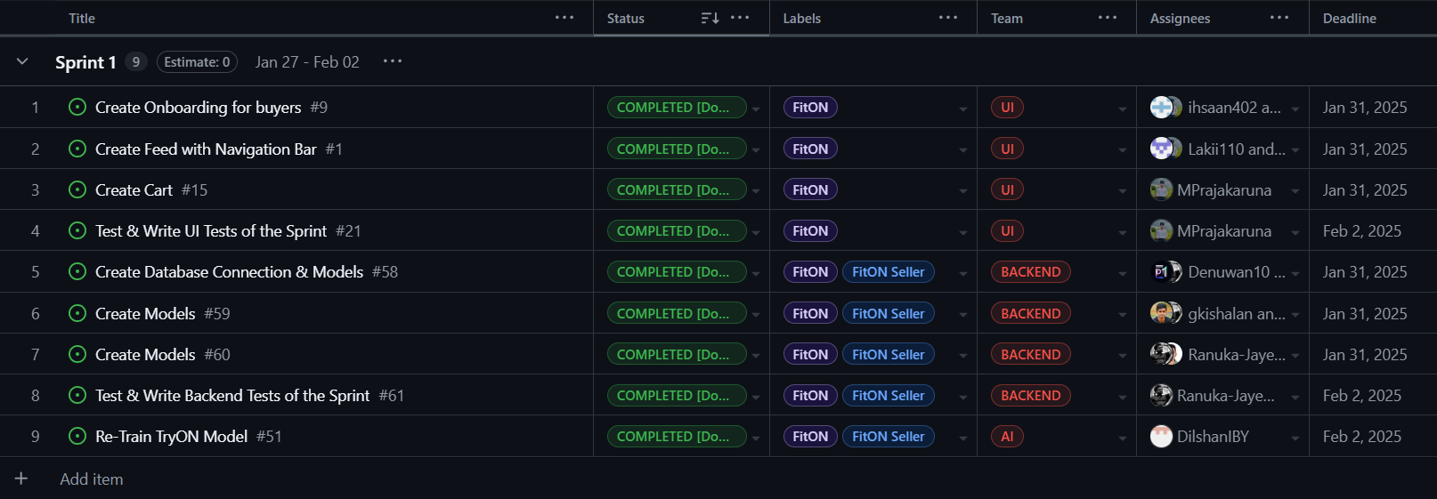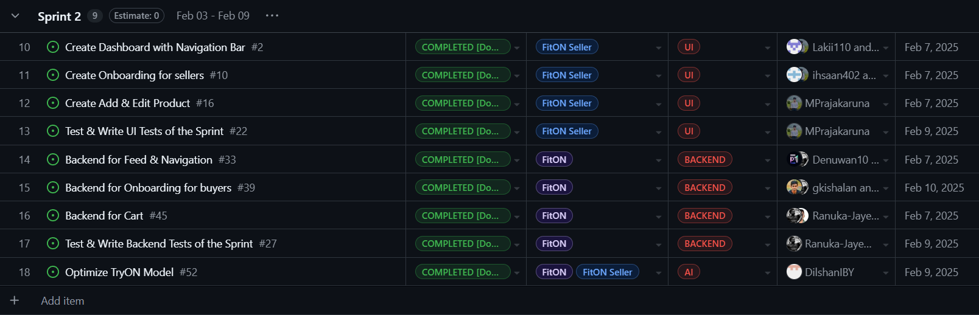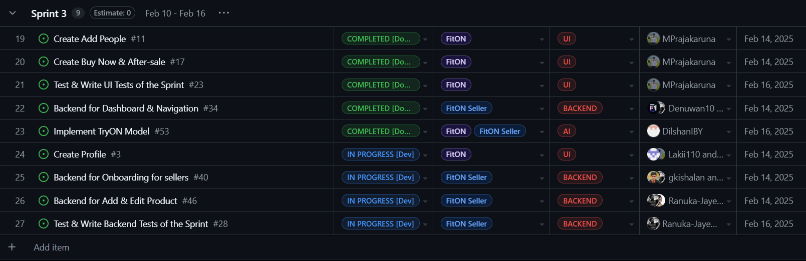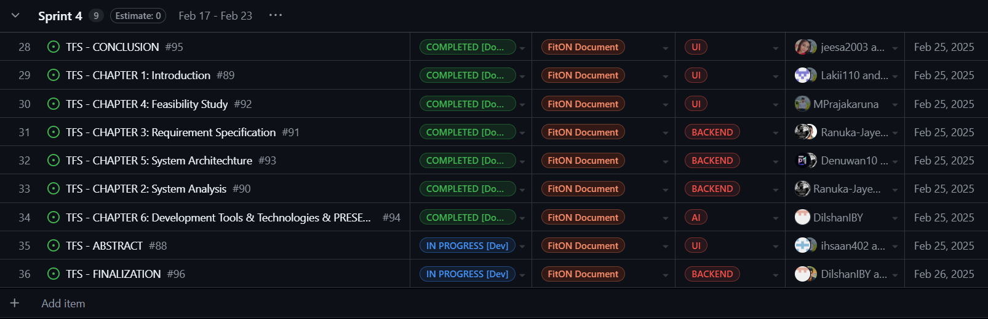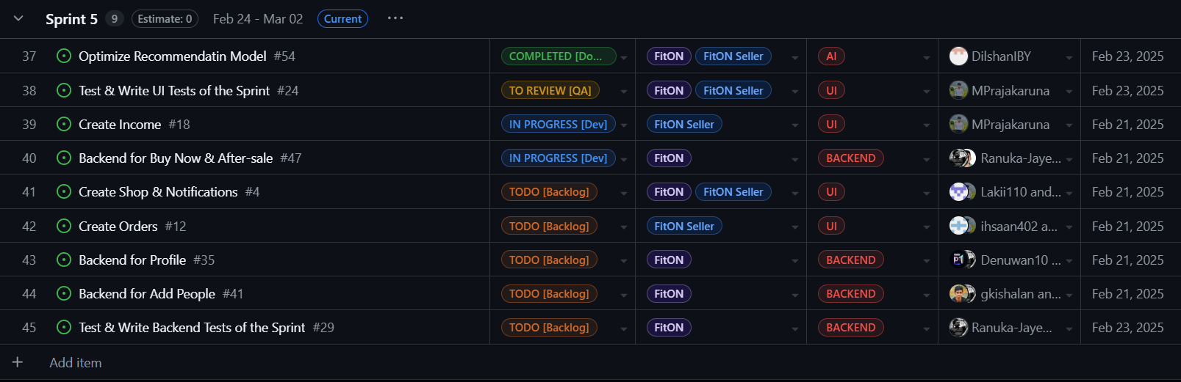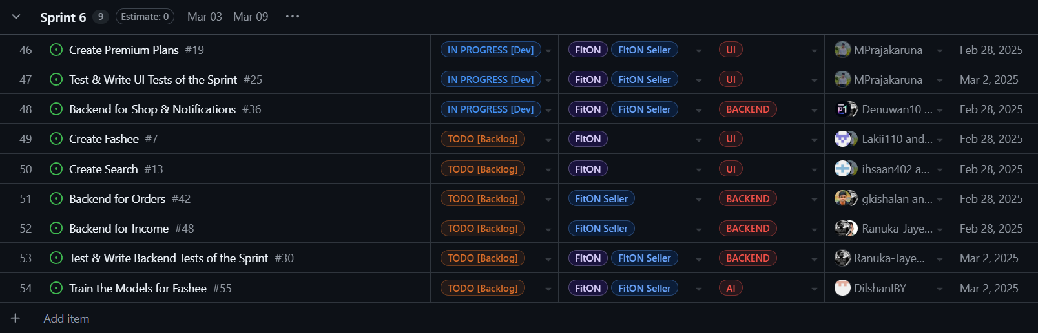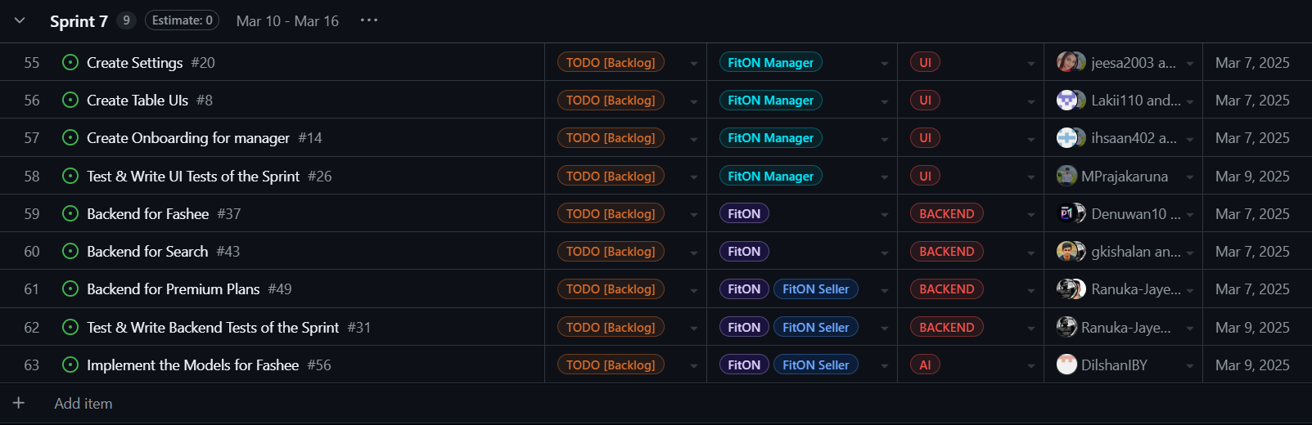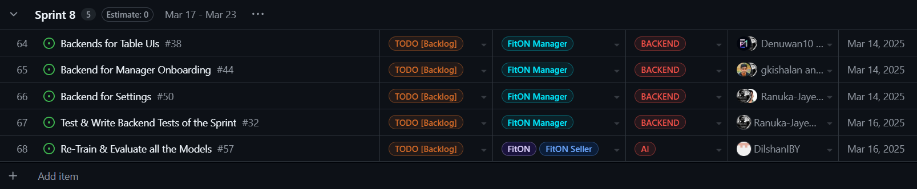

### 6.1.4. Project Timeline

Table . Agile Timeline

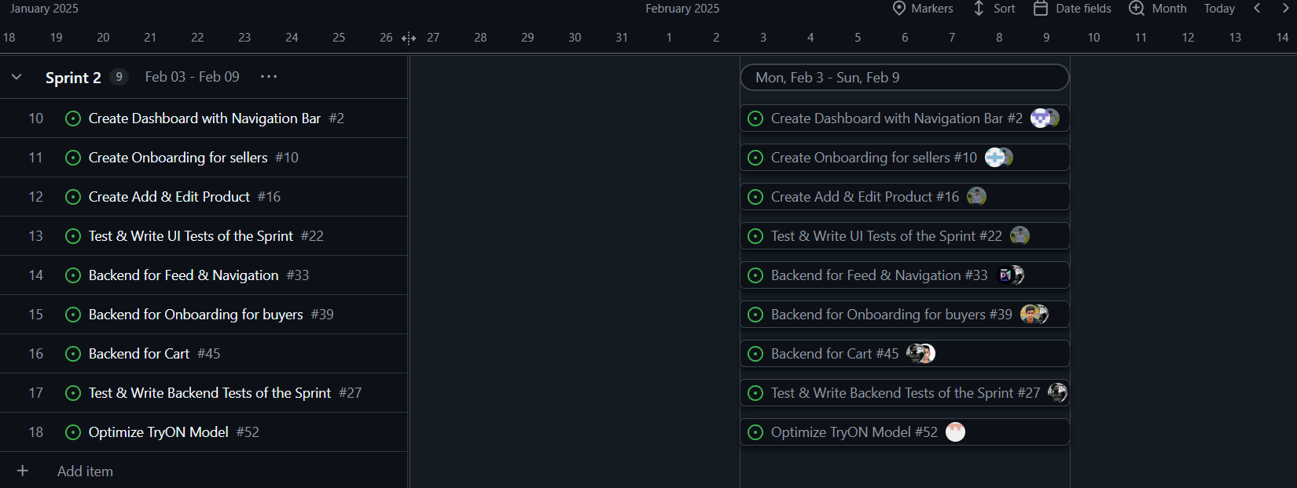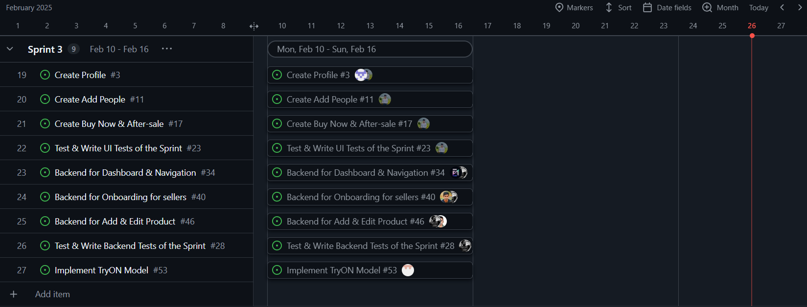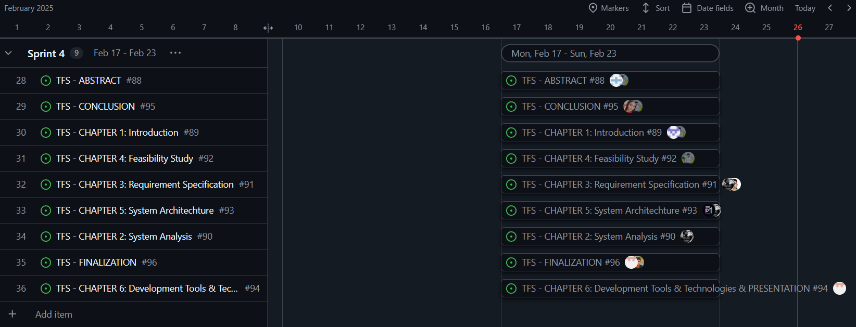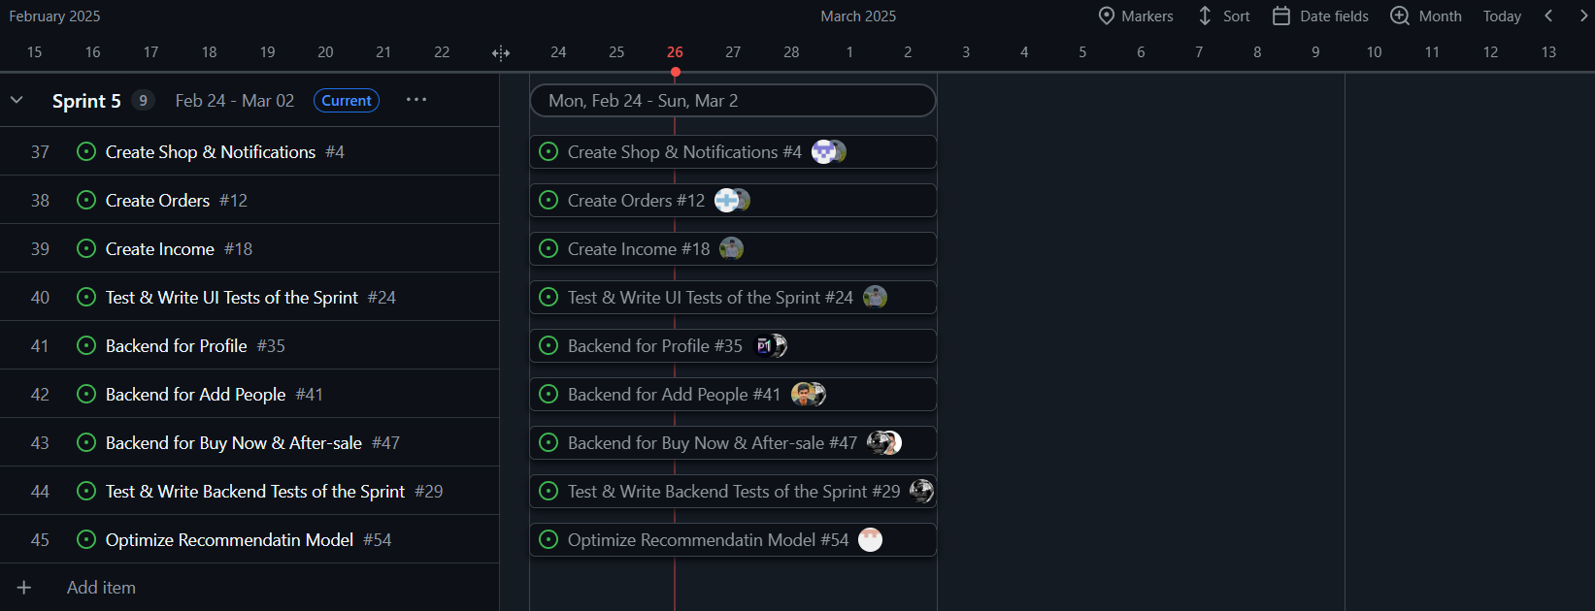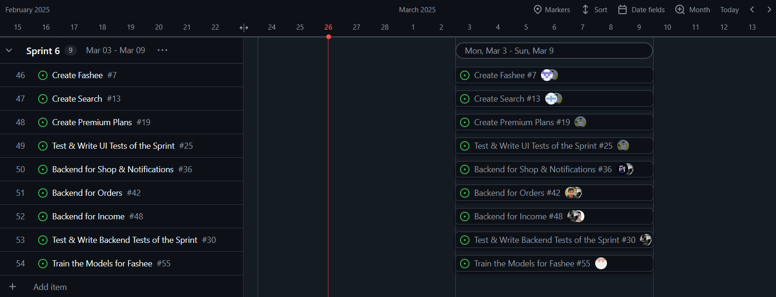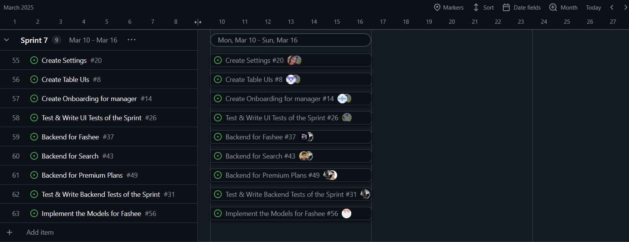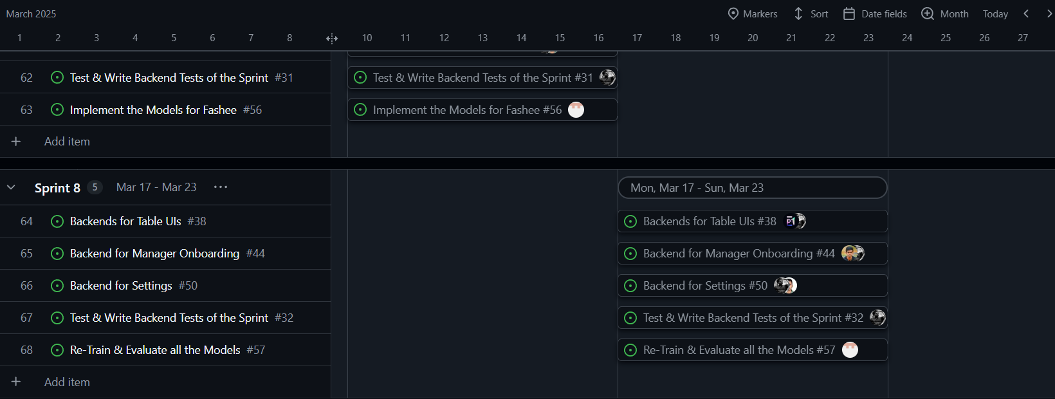

# 6.2. Programming Languages & Tools

### 6.2.1. Main Languages & Frameworks

#### Flutter

* **Version**: 3.29.0
* **Purpose**: The main framework for developing the FitON mobile applications(FitON & FitON Seller), ensuring cross-platform compatibility (Cai, et al., 2021) for both Android and iOS.

#### Dart

* **Version**: 3.8.0
* **Purpose**: The main and mother programming language used with Flutter to build UI components and manage application logic.

#### Python

* **Version**: 3.13.2
* **Purpose**: Used for AI model development, backend services, and data processing.

#### Node.js

* **Version**: 22.14.0
* **Purpose**: Backend API development, handling authentication, database interactions, and business logic.

### 6.2.2. Tools

#### Supabase (PostgreSQL)

* **Purpose**: The database management system used to store user, product, and transaction data.

#### Firebase

* **Purpose**: Provides authentication, cloud storage, and real-time database functionalities.

#### Google Vertex AI

* **Version**: M126
* **Purpose**: To manage data analysis and implement AI models.

#### Google Colab

* **Purpose**: The Online IDE that used to AI Model Development and Training.

#### AdMob

* **SDK Version**: 24.0.0
* **Purpose**: Manages advertisements within the application for revenue generation.

#### Stripe/PayPal API

* **Version**: v2
* **Purpose**: Payment processing (PayPal Inc, 2024) (Stripe Inc, 2024) and secure transaction management.

#### TensorFlow

* **Version**: 2.16.1
* **Purpose**: AI model training and deployment for the virtual try-on and recommendation systems.

#### GitHub

* **Purpose**: For version Control and Project Management.

# 6.3. Algorithms

The FitON system uses a number of very special algorithms to improve user experience and offer unique features like personalized recommendations and virtual try-ons.

### 6.3.1. AI-Based - Virtual Try-On Algorithm

The **Virtual Try-On model** (Smith & Doe, 2023) here is a deep learning-based CNN algorithm used to generate realistic try-on images of garments on users. The algorithm maintains natural body structure and fabric realism while processing user-uploaded photos and applying garment items.

**Flow Chart:**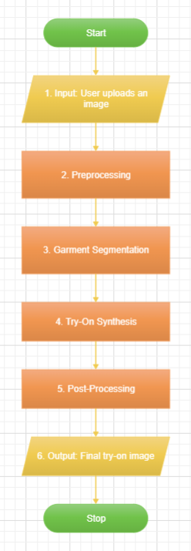

1. **Input**: User uploads an image.
2. **Preprocessing**: Image is normalized, background is removed, and pose estimation is performed.
3. **Garment Segmentation**: The clothing item is segmented and adjusted for alignment.
4. **Try-On Synthesis**: The model overlays the clothing onto the user image.
5. **Post-Processing**: Final adjustments are made to enhance realism.
6. **Output**: The final try-on image is generated and displayed to the user.

Figure . Virtual Try On Algorithm [Flow Chart]

### 6.3.2. AI-Based - Personalized Recommendation Algorithm (BERT4Rec)

BERT4Rec (Sun, F; Liu, J; Wu, J; Pei, C; Lin, X; Ou, W; Jiang, P; Wang, X, 2019) is a **deep learning-based recommendation system** that uses “bidirectional transformers” to analyze user interactions and suggest relevant clothing items based on browsing behavior, purchase history, and personal preferences.

**Flow Chart:**

1. **Input**: Implicit and explicit data gathered from user activities. (clicks, purchases, wishlist items).
2. **Data Encoding**: User interactions are tokenized and embedded.
3. **Transformer Model**: BERT processes the data to predict the next likely preferred item.
4. **Ranking & Filtering**: Recommendations are ranked based on relevance.
5. **Output**: Personalized suggestions are displayed in the app.

Figure . Clothing Recommendation Algorithm [Flow Chart]

### 6.3.3. AI-Based - Fashee Chat Algorithm

The **Fashee Chat Algorithm** powers the AI-based fashion assistant, allowing users to receive personalized styling advice. It is based on Natural Language Processing (NLP) to analyze user queries and generate fashion recommendation texts and images based on current trends and user’s personal preferences.

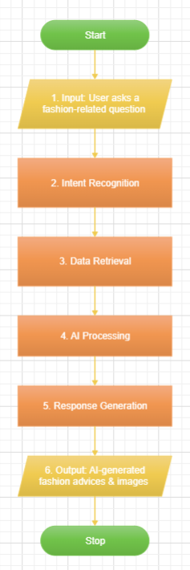**Flow Chart:**

1. **Input**: User inputs a fashion-related query (e.g., "What should I wear for a wedding?").
2. **Intent Recognition**: NLP model detects the intent (e.g., occasion-based styling).
3. **Data Retrieval**: Fetches relevant styling tips and clothing recommendations.
4. **AI Processing**: Uses machine learning to refine recommendations based on user history.
5. **Response Generation**: Outputs a response with suggested outfits and styling tips.
6. **Output**: User receives AI-generated fashion advice in a chat interface.

Figure . Fashion Assistant Algorithm [Flow Chart]

# 6.4. Chapter Summary

This chapter is about a comprehensive overview of the **Development Tools & Technologies** used in the FitON Applications. It covers:

1. **SDLC Methodology - Agile Scrum**, introducing the iterative approach and sprint-based development process.
2. **Programming Languages, Tools & Frameworks**, explaining the key technologies enabling cross-platform functionality and backend services.
3. **Algorithms**, explaining the AI-driven features such as virtual try-on, personalized recommendations, and the Fashee Chat assistant.

Together, these parts confirm a user-focused, scalable, and effective solution.

# References

* Cai, W., Guo, J., Tang, X. & Xiao, X., 2021. Cross-platform mobile development with Flutter: Analysis and application. *International Journal of Interactive Mobile Technologies,* 15(5), pp. 103-120.
* PayPal Inc, 2024. *Buyer Protection and Dispute Resolution Policies.* [Online]   
  Available at: https://www.paypal.com  
  [Accessed 18 February 2025].
* Schreiner, M; Sluyter, M;, 2021. *Agile for Dummies.* 2nd ed. Hoboken: NJ: John Wiley & Sons, Inc.
* Smith, A. & Doe, J., 2023. Enhancing Online Shopping with Virtual Try-On Technology. *Journal of E-commerce,* 12(3), pp. 34-45.
* Stripe Inc, 2024. *Dispute and Chargeback Process.* [Online]   
  Available at: https://www.stripe.com  
  [Accessed 18 February 2025].
* Sun, F; Liu, J; Wu, J; Pei, C; Lin, X; Ou, W; Jiang, P; Wang, X, 2019. *BERT4Rec: Sequential Recommendation with Bidirectional Encoder Representations from Transformer.* s.l., Proceedings of the 28th ACM International Conference on Information and Knowledge Management (CIKM).

# Appendixes

### Team Structure

Figure . Organizational View